**PUBLIC SERVICE SOCIAL SECURITY FUND**



**SOFTWARE REQUIREMENT SPECIFICATION (SRS) TEMPLATE**

|  |  |
| --- | --- |
| **Project Title** | ONLINE MEMBER REGISTRATION AND CLAIM SUBMISSION (PAPERLESS) |
| **Version Approved** |  |
| **Prepared by** |  |
| **Organization** | PSSSF |
| **Date Created** |  |

**Revision History**

|  |  |  |  |
| --- | --- | --- | --- |
| **Name** | **Date** | **Reasons for Changes** | **Version** |
|  |  |  |  |
|  |  |  |  |

**Table of contents**

Table of Contents

**1** **Introduction** 3

**1.1** **Purpose** 3

**1.2** **Document Conventions** 3

**1.3** **Intended Audience and Reading Suggestions** 3

**1.4** **Product scope** 3

**1.5** **References** 3

**2** **Overall Description** 3

**2.1** **Product perspective** 3

**2.2** **Product functions** 4

**2.3** **User classes and characteristics** 4

**2.4** **Operating environment** 4

**2.5** **Design and implementation constraints** 4

**2.6** **User documentation** 4

**2.7** **Assumptions and Dependencies** 5

**3** **External Interface requirements** 5

**3.1** **User interfaces** 5

**3.2** **Hardware interfaces** 5

**3.3** **Software interfaces** 5

**3.4** **Communication interfaces** 6

**4** **System Features** 6

**4.1** **System feature 1** 6

**4.1.1** **Description and priority** 6

**4.1.2** **Stimulus/response sequences** 6

**4.1.3** **Functional requirements** 6

**4.2** **System feature 2 (and so on)** 7

**5** **Other non-functional requirements** 7

**5.1** **Performance requirements** 7

**5.2** **Safety requirements** 7

**5.3** **Security requirements** 7

**5.4** **Software Quality Attributes** 7

**5.5** **Business Rules** 8

**6** **Other Requirements** 8

# **Introduction**

## **Purpose**

PSSSF online member registration and claim submission is the application which will allow employer to submit claims through PSSSF employer portal and member to be registered online without a need of physical submission. This application will increase Funds efficiency by reducing scanning of submission forms in collaboration with Laserfiche Web Portal, saving costs of ink, toner, and printing of registration and claim forms, Digital files are clearly not at risk of being destroyed in a fire or stolen, a digitized office saves the hassle of filing and storing documents in a cabinet, a paperless office quickens all processes and It boosts operational efficiency while being easily connected with the employers.

## **Document Conventions**

While writing for SRS document we have made the following conventions and adopted the IEEE Standards

Font used – Tahoma

For main headings font size – 18

For subheadings font size- 14

For Normal Text- 12

Headings are highlighted in bold

Document text is single spaced and maintains the 1” margin.

## **Intended Audience and Reading Suggestions**

The document is intended for developers, members of management and other users. The SRS document contains overall descriptions, specific requirements, and other non-functional requirements of the application.

## **Product scope**

The system is made in Laravel framework using PHP programming language and MySQL and oracle database. The objective of the system is to enable employer to submit claims and member to be registered online through PSSSF employer portal without a need of physical submission hence it will increase operational efficiency while being easily connected with the employers.

# **Overall Description**

## **Product perspective**

PSSSF online member registration and claim submission application will be a web service, which is going to be hosted on a server, which contains the PSSSF online member registration and claim submission application, and the database server. Application will be using open source language PHP that is also a web-based language.

All the coding will be created in PHP language. Application can be run through any browser like Mozilla, internet explorer. Google chrome etc. User must have the login and the password to use the application.

## **Product functions**

The major functions of the PSSSF Share System are -

* Claim Registration
* Employer Claim Verification
* Member Claim Acceptance (Internal – Records)
* Online member registration form in the member registration portal
* Employer verify online member registration form
* Zone/Regional Office Receive Online member registration form
* Record Officer Member registration in MAS
* Online Employer Registration
* New Member Portal User Registration
* Member Portal User Login

## **User classes and characteristics**

Users of the PSSSF online member registration and claim submission application should be able to access and login to the system, to register claim based on populated benefit type, to allow employer to verify Registered claim, to allow Records Officer to verify Claim, to fill Online member registration form in the member registration portal and new Member Portal User to register and login.

## **Operating environment**

Operating environment for the PSSSF online member registration and claim submission is as listed below

* Client/Server System
* Operating system: Linux
* Database: MySQL/Oracle
* Platform: Laravel framework

## **Design and implementation constraints**

PSSSF online member registration and claim submission requires a web server connected to the internet; a programming language for describing the application logic; a server engine for generating the dynamic, a database to provide a way of storing and retrieving large amounts of data. Only application administrator has the right to change the application parameters. The application should be secure and must use encryption to protect the databases.

## **User documentation**

* User should know the details of the working being done in the system
* User should be comfortable with how does the system works.

## **Assumptions and Dependencies**

All the hardware would function properly and all the information provided by the user should be correct to avoid any sort of problem regarding relationship with the customer.

* The user should be login to the system
* Access is dependent on basis of the level
* The user is an authorized one.

# **External Interface requirements**

## **User interfaces**

* Front-end application: HTML and JS(browser )

## **Hardware interfaces**

* Pentium IV Processor, 1GB
* Minimum 128 MB RAM, Recommendable 512 MB
* Minimum 20 GB Hard Disk, Recommendable 80 GB

## **Software interfaces**

Following are the software used for the PSSSF online member registration and claim submission.

|  |  |
| --- | --- |
| Software used | Description |
| Operating System | We have chosen Linux operating systems for security reasons. |
| Database | To save the PSSSF online member registration and claim submission records we have chosen MySQL and Oracle database |
| PHP | To implement the project we use PHP language for its more interactive support. |

## **Communication interfaces**

The Communication Between users and the administrator takes place through E-mail and SMS (mobile phone number). It requires a web browser at the client side and a web server at the Server Side. The communication standards that will be used is HTTPS. The system should be secure and must use encryption to protect the databases. Users need to be authenticated before having access to any information in the system.

# **System Features**

### **Description and priority**

In this application, data access is given to the user based on their category. Each user will have the same level of priority with the other.

### **Stimulus/response sequences**

* User Registration
* User Login after successful registration
* Claim Registration
* Employer Claim Verification
* Member Claim Acceptance (Internal – Records)
* Online member registration form in the member registration portal
* Employer verify online member registration form
* Zone/Regional Office Receive Online member registration form
* Record Officer Member registration in MAS
* Log out

### **Functional requirements**

**User Registration Module:**

* Create New User Account
* User Login
* User Logout

**Claim Registration Module:**

* Register claim based on populated benefit type
* Attach claim type documents based on claim type
* Fill claim registration form and save prior to submit

**Employer Claim Verification Module:**

* Employer verify Registered claim
* Employer register claim
* Employer view/track progress(status) of claim for individual members
* Send notification (sms) to member upon submission of claim to the Fund

**Member Claim Acceptance (Internal – Records) Module:**

* Records Officer verify Claim
* Records officer Reject claim with Rejected Reason
* Records supervisor to assign and re-assign claims to records officers

**Online member registration form in the member registration portal:**

* Employer generate registration number (special registration code) that will be expired over a time
* User Submit completed form to the Employer for verification

**Online Member Record Updating**

* Register application for amendment of member details by filling online updating request form
* Member should be able to fill updating request form and save prior to submit
* Allow member to view rejected application for updating member details and its reason

# **Other non-functional requirements**

## **Performance requirements**

In PSSSF online member registration and claim submission, performance should be preserved in such a way that a system becomes available, as there should be fewer or low level of downtimes in a system. In addition, it completes the updates in case there is an event of updating various daily dealings in a system.

## **Safety requirements**

The system should be user friendly(Nurdin),language that will be used will not mislead user

## **Security requirements**

* Only system administer has the right to change system parameters.
* The system should be secure and must use encryption to protect the databases.
* Users need to be authenticated before having access to any data in the system.

## **Software Quality Attributes**

**Availability:**

* + - Will be available 24 hours

**Correctness:**

* The system should show the correct information(authentic and uptodate information)

**Maintainability:**

* Easy and efficient way to add new features (for fixing Bugs, Modification).

**Usability:**

* Providing simple navigation
* System provide Clear and Concise Contents

**Scalability:**

* System is capable of handling large number of Users and large volume of information.
* **Interoperability:**

Will be intergrated with other systems

## **Business Rules**

roles can perform which functions under specific circumstances

# **Other Requirements**

* System providing output of reports in various formats such as Microsoft applications, XML, ASCII or PDF

**Appendix A: Glossary**

**PSSSF:** Public Service Social Security Fund

**SRS:** is a document or set of documentation that describes the features and behaviour of a system or software application

* GUI, XML, ASCII or PDF

**Appendix B: Analysis Models**

# **USE CASES**

|  |  |  |
| --- | --- | --- |
| 1. **User Registration .** | | |
|  | **Process** | **Actor** |
|  | Enter First name. | User |
|  | Enter Middle name | User |
|  | Enter Surname | User |
|  | Enter Password. | User |
|  | Enter email address | User |
|  | Reenter Password to confirm. | User |
|  | Submit registration | User |
|  | Send registration confirmation to email address | System |

|  |  |  |
| --- | --- | --- |
| 1. **Claim Registration** | | |
|  | **Process** | **Actor** |
|  | Enter benefit type | User |
|  | Attach claim type documents based on claim type | User |
|  | View Claim progress status | User |
|  | Send special code for verification | System |
|  | Alert both Employer and Employee for Maternity remaining eligible period | System |
|  | Fill claim registration form and save prior to submit | User |
|  | Capture received date as date of employer submit claim to the Fund | System |
|  | Allow only one active claim and one fresh claim | System |
|  | View rejected registration and its reason | User |
|  | Generate tracking number using USSD code/sms – ( Random number- 4 digit) | System |

|  |  |  |
| --- | --- | --- |
| 1. **Employer Claim Verification** | | |
|  | **Process** | **Actor** |
|  | Verify Registered claim | Employer |
|  | Sign a generated disclaimer | Employer |
|  | Register claim | Employer |
|  | View/track progress(status) of claim for individual members | Employer |
|  | Send notification (sms) to member upon submission of claim to the Fund | System |
|  | Verify/not verify individual document prior receive of Claim | Employer |
|  | Send notification (email) to DHRA responsible on claim submitted to the Fund for information | System |
|  | Accept or reject claim with rejection reason | Employer |

|  |  |  |
| --- | --- | --- |
| 1. **Member Claim Acceptance (Internal – Records)** | | |
|  | **Process** | **Actor** |
|  | Verify Registered claim | Record Officer |
|  | Reject claim with Rejected Reason | Record Officer |
|  | Receive Claim (auto registration of claim) | Record Officer |
|  | Review rejected Claims before sent to Member/Employer | Record Supervisor |
|  | Registration of claims based on Employer allocated Region | System |
|  | Verify/not verify individual document prior receive of Claim | Record Officer |
|  | Assign and re-assign claims to records officers | Record Supervisor |
|  | View claim in their inbox after being assigned by  supervisor | Record Officer |
|  | Change crucial submitted details | Record Officer |
|  | Add Rejected Reason | Record Supervisor |

|  |  |  |
| --- | --- | --- |
| 1. **Online member registration** | | |
|  | **Process** | **Actor** |
|  | Generate registration number (special registration code) that will be expired over a time | Employer |
|  | Enter registration number (special registration code) provided by his/her Employer during registration to the Fund | Employee |
|  | Attach copy of National Identity Card and first appointment letter | Employee |
|  | Submit completed form to the Employer for verification | Employee |
|  | Check the existence of both NIDA Number and Member Number | System |
|  | Save progress during online registration process and submit when the process is completed | Employee |
|  | Restrict submission if any of the mandatory field is no completed. | System |
|  | Capture employee signature from NIDA Database in the Employee’s Declaration part | System |
|  | Verify Online member registration form | Employer |
|  | Receive Online member registration form | Zone/Regional Office |
|  | Register member in MAS once record officer accept registration | System |

|  |  |  |
| --- | --- | --- |
| **6.0 Online Member Record Updating** | | |
|  | **Process** | **Actor** |
|  | Login first using member number or National ID Number | Member |
|  | Register application for amendment of member details by filling online updating request form | Member |
|  | Send notification (sms) to member upon submission of application to the Fund | System |
|  | Attach supportive documents to be uploaded and submit request employer for verification | Member |
|  | View application progress status | Member |
|  | Verify Registered application for updating of member details | Employer |
|  | Upload supportive document | Employer |
|  | Accept or reject application for updating of member details with rejection reason | Employer |

**ENTITY RELATIONSHIP DIAGRAM**

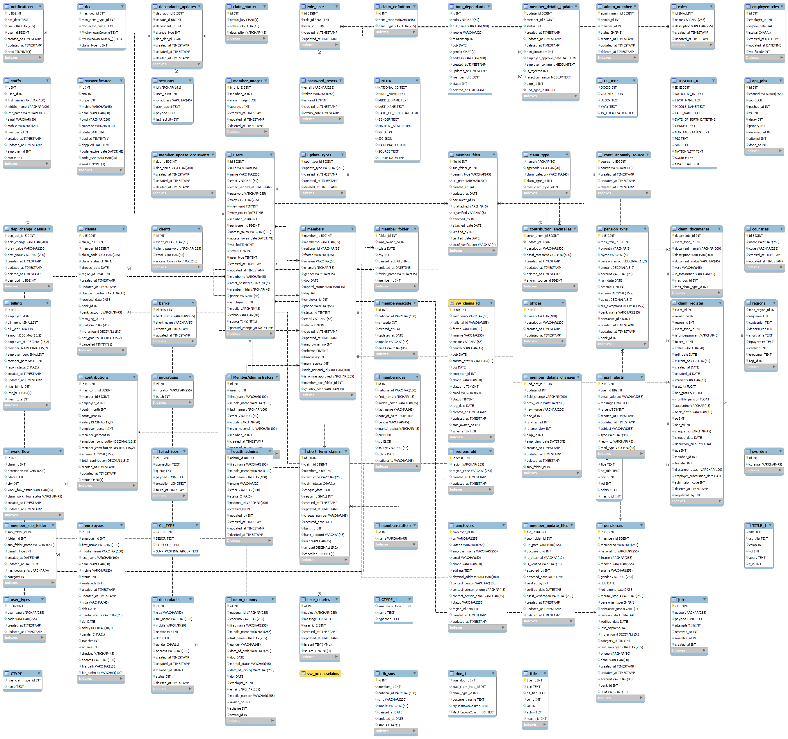

**WORKFLOW PROCESS DESIGN**

**1: MEMBER REGISTRATION WORKFLOW**

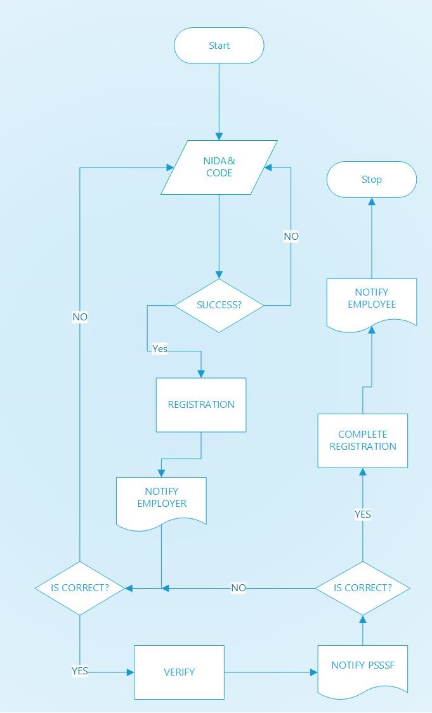

**2: CLAIM REGISTRATION WORKFLOW**

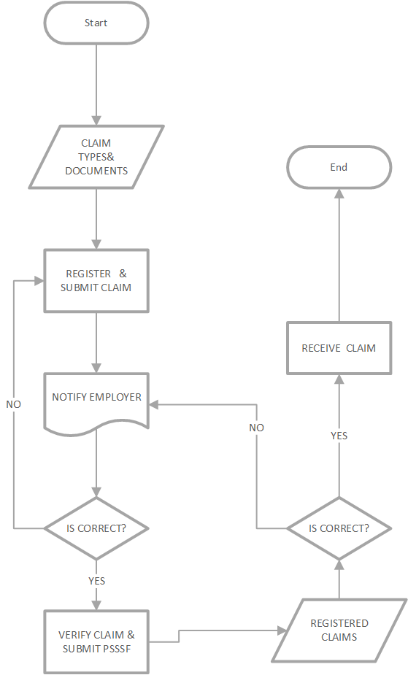

**Appendix C: To Be Determined List**

|  |  |  |  |
| --- | --- | --- | --- |
| **ACTIVITY** | **TASKS** | **DELIVERABLES** | **TIMEFRAME** |
| System design and programming | Construct database for the back-end Oracle and MySQL  Construct interface for the front- end  PHP | Database systems;  User interface | 4 weeks |
| Testing | Test functionality and compatibility of the system | Demonstration | 2 weeks |
| System finalization | Deliver final presentation; Launch system | Oral presentation | 1 week |